From the Director of Building Better Futures

One of the important ways we can advance the project management discipline is to introduce the concepts at schools. As the Associate Director of the BBF in Schools program My Tran Le and her team of volunteers face the challenge of making project techniques relevant to students and teachers while demonstrating the benefits of PM through engaging exercises. Below, My Tran provides the latest on this important program that helps to seed interest in project management and develop future project professionals.
The BBF in Schools Program was relaunched late last year and we are very excited about the plans lined up for this year to promote and deliver the program to the schools.
The BBF Schools program's goal is to promote the benefits of project management in schools and provide students and teachers with skills they can use in the school and their everyday lives; building future leaders of tomorrow. Not only will they be equipped to manage their day-to-day activities but also assisted to make important decision in their personal life journey.
We have recently developed “A Taste of Project Management for Schools” and delivered this to the teachers at Ashfield Boys High School in March, 2014. This new service from the BBF Schools program provides a summary of the various pieces of the project management puzzle, giving the schools a taste of what’s involved in the teachers/students program. Daisy Kokkalis, the Principal at Ashfield Boys High School, provided great support to this program.
Our next teacher’s program is planned at Liverpool Girls High School in the coming months. We have also been working closely with the University Connect team to build partnerships between the BBF Schools program and universities across the state. With the emergence of undergraduate degrees in project management, making school students aware of these new career paths becomes all the more important.
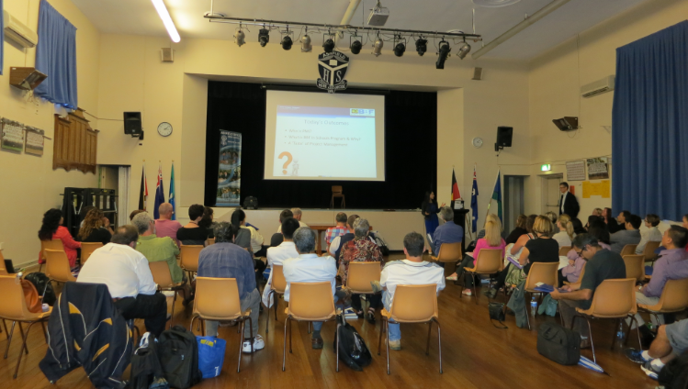
A Taste Of Project Management, Ashfield Boys High School, March 2014
Being a volunteer of the BBF Schools program for the last four years, I have seen this program morph from an idea to reality. As an original team member putting together the iPM4You (Introduction to Project Management for Youth) I have seen it become the foundation of the successful BBF Schools program we have today. It has been a tremendously rewarding experience, especially when I witness the benefits the students have received from the program.
All this progress only happens because of the efforts of a dedicated group of volunteers. A great BIG thank you goes to our current team members – Jigish Mehta, Simon Bromage, Hazel A, Praveen Jomy and Karina Ahlburg for their passion and ongoing contribution to this program.
If you would like to nominate a school to participate in this program, or if you, like us, believe that having project management skills has improved your life, then HOP ON! Join us as a volunteer and share in our mission to build better futures in our community! Please contact me on bbfschools@pmisydney.org.

Good things happen when you get involved in PMI Sydney!
November 2013 | Volume 5 Issue 6

